17 May 2025, Saturday 19:00

Smart Waste Sorting System: Machine Learning Model
Analysis and Reporting
Lecturer: Ruchen Wyngaard
Iman Abdurahman 4346142
UWC IFS315
Table of Contents
Introduction 1
Data Collection and Preprocessing 1
Model Development 2
Model Architecture 2
Model Training 2
Evaluation 2
Metrics 2
Classification Report 3
Strengths 3
Limitations 4
Testing with Webcam Input 4
Ethical Considerations 4
Responsible Use 5
Real-World Applications 5
Conclusion 5
Appendices 6
Appendix A – Confusion matrix output and AUC-ROC Score 6
Appendix B – Classification Report and Dataset 7
Appendix C – Results of ML Model Tests 8
Appendix D – References 9

Introduction
With the global pollution and waste levels rising, waste classification and an ecological waste management approaches remains a significant challenge in modern environmental sustainability. The aim of this project is to design and implement a machine learning-based vision system that can effectively classify waste into 5 categories using a Convolutional Neural Network (CNN) model. This project will not only addresses real-world challenges in waste management but also acts as an opportunity to gain practical experience with supervised learning, transfer learning and real-time image classification.

Data Collection and Preprocessing
In order to develop a reliable and robust machine learning model, I used various sources to collect images to form my dataset. All the images were sorted into 1 of the 5 classes: Glass, Metal, Paper, Plastic, or Organic Material. The images varied in resolution and lighting conditions which helped the model generalise better to real-world scenarios.
Sources:
- GitHub repositories provided me with labelled image datasets for majority of my waste classification categories. I then extracted the images I found useful for my own dataset.
- Google Images using focused search terms to get additional samples for less-represented categories such as organic materials.
- Manual collection using my smartphone camera and household items.
Preprocessing steps:
- Resizing all images to 224×224 pixels to match MobileNetV2 input dimensions.
- Normalisation to scale pixel values between 0 and 1 (helps to standardise input).
- Data augmentation including random rotations, flips, and zooms to increase data variability and reduce the risk of overfitting.
The dataset split:
- Training set: 1261 images (+/- 80%)
- Validation set: 358 images (+/- 20%)
- Testing set: 368 images (+/- 20%)

Model Development
My model was developed using TensorFlow and Keras with MobileNetV2 serving as the base architecture for transfer learning. I chose MobileNetV2 as it had a lightweight structure and should therefore be efficient on mobile devices or embedded systems. It also is proven to have a high performance in image classification tasks.
Model Architecture:
- Base model: MobileNetV2 (pre-trained on ImageNet: The base layers were frozen initially to prevent overfitting in early training stages)
- Custom head:
  - GlobalAveragePooling2D - Converts feature maps into a single vector by averaging the values across the map.
  - Dense layer - A fully connected layer with 128 neurons and ReLU activation.
  - Dropout (rate = 0.5) - Reduces overfitting by randomly dropping 50% of the neurons during training.
  - Output Dense layer - An output layer with 5 units that represent the different types of waste.
Model Training:
The model was trained for 10 epochs using the Adam optimizer with a learning rate of 0.0001 and Categorical crossentropy as the loss function. Categorical crossentropy was selected as it’s suitable for multi-class classification. Early stopping technique was also considered but not implemented due to the stable performance improvement throughout the training epochs.

Evaluation
The model achieved strong results on unseen test data:
Final test accuracy: 90.49% Validation accuracy: Peaked at 88.83%
Metrics:
- Precision, Recall and F1-Score:
These metrics provide insights into the model’s strengths and weaknesses for each class by assessing the balance between correct identification and missed/incorrect predictions for each category. Precision concentrates on the accuracy of positive predictions whereas Recall measures the model's ability to identify positive cases. F1 score is useful when you need a balance between precision and recall, especially in scenarios with no obvious trade-off choice.
- Confusion Matrix: (Refer to Appendix B and Limitations)
A visual breakdown of predictions versus actual labels, highlighting which classes are most often confused.
  - Metal is highly accurate with only minor misclassifications. It has most confusion was with glass and plastic which is likely due to similar colours or reflection patterns in images.
- AUC-ROC Score (Refer to Appendix A):
Achieved a score of 0.9877 showing an excellent discriminative ability across all classes. This suggests the model can confidently distinguish between the different types of waste even when the input images contain visual noise or uncertain features.
Classification Report:
(Refer to Appendix A)
- Organic Material achieved perfect recall (1.00) and very high precision - indicates that the model never missed any organic waste in the test set and almost never mislabelled others as organic.
- Metal performed well with recall at 93.51% and a slightly lower precision at 86.75% - suggests that it rarely miss interpreted but the model occasionally mislabels other classes as metal.
- Plastic had a high precision of 90.70% but lower recall at 82.98% - shows us that the model is conservative when predicting plastic but some plastic items were missed.
- Glass was the lowest-performing class in terms of precision and recall - there is a noticeable confusion with the plastic and metal classes.
Strengths:
- Excellent Recall for Organic and Metal Waste:
It suggests that the model demonstrated strong sensitivity to these classes as organic waste was always correctly identified and metal was only misclassified in a few cases.
- Consistent Class Performance:
All 5 classes achieved an F1-score above 0.83, reflecting the model’s balanced performance and strong generalisation across diverse input conditions.
- Excellent discriminative ability:
A macro-averaged ROC-AUC of 0.9861.
Limitations:
- Confusion between glass and plastic:
The most common reason for confusion stemmed from the visual similarity between glass and plastic, especially under certain lighting or angles. 6 out of 70 actual glass samples were misclassified as plastic. This reflects visual overlap (e.g. transparency, light reflection or shine) and could be improved with more diverse training images.
- Lower Recall for Plastic:
Indicates that a number of plastic waste went unrecognised, possibly due to background noise or unclear features in real-world photos. Plastic samples were occasionally misclassified across several classes (In most cases it was confused with glass and metal). This indicates a need for enhanced feature differentiation, possibly through additional augmentation or fine-tuning.
- Sensitivity to unidentified Features:
A few misclassifications may arise from the model unintentionally learning irrelevant contextual clues (e.g. table surfaces or lighting) rather than waste-specific features.

Testing with Webcam Input
A real-time prediction system using a webcam was developed with OpenCV and TensorFlow to assess the model's live performance. It processes camera frames using the same preprocessing development and predicts waste type using the trained MobileNetV2 model, displaying results instantly. This demonstrates the model's readiness for real-world applications like smart bins or mobile waste-sorting tools.

Ethical Considerations
Deploying AI systems in real-world settings brings important ethical responsibilities. A primary concern is user privacy. Any system using live webcam input must be designed to ensure that no personal or sensitive information is captured or stored. Developers should comply with relevant privacy laws and data protection regulations (e.g. POPI), especially in public or shared environments. Another major consideration is bias. To reduce it, training data should represent a wide variety of object appearances (e.g. plastic items of different backgrounds, colours and sizes) ensuring fair and consistent model performance across diverse contexts.

Responsible Use
Beyond ethics, the responsible use of this model involves transparency, accountability and continuous improvement. Users should be informed about the system’s capabilities and its limitations as well as the possibility of misclassification. To reduce misuse, thorough documentation should accompany the system, outlining the intended use cases and cautioning against deploying it as the sole decision-maker in critical applications.
Responsible use includes features like manual overrides, real-time performance monitoring, and regular model updates to adapt to changing waste types. Sourcing local data further boosts accuracy and relevance. These practices support safe, effective deployment and help build trust in AI-driven sustainability solutions.

Real-World Applications
Impactful use cases:
- Smart Waste Bins: Automated sorting bins in public to reduce contamination in recycling streams.
- Municipal Waste Management: Improved input and accuracy in sorting lines at recycling centres.
- Mobile Apps: Real-time waste identification (application or website) on smartphones to guide users on how to properly dispose of household items.

Conclusion
This project demonstrates successful development and integration of computer vision, machine learning and real-time prediction to tackle environmental challenges. Through careful data curation, transfer learning and evaluation, the model achieves over 90% accuracy on diverse data. While limitations such as class overlapping and background noise still remain in the works for improvement, the system shows promise for integration into smart recycling solutions. This could one day significantly help the community and environmental movements in achieving ethical and eco-friendly living.

Appendices

Appendix A – Confusion matrix output and AUC-ROC Score
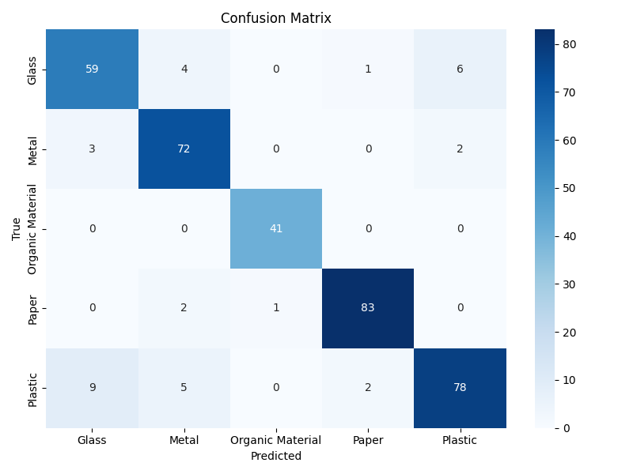

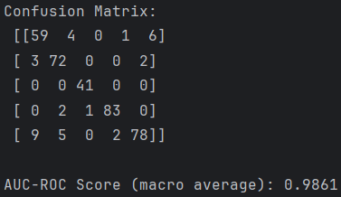
Figure 1: Heatmap

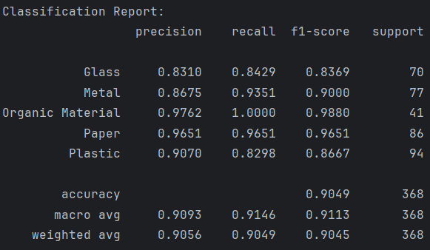
Appendix B – Classification Report and Dataset

https://drive.google.com/drive/folders/1kClOgn-O7z-LQRd6TAzWOkXAQHKa43Bg?usp=drive_link
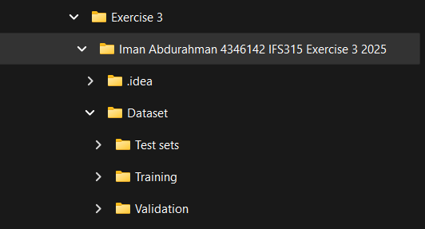
Figure 2: Folder structure

Appendix C – Results of ML Model Tests
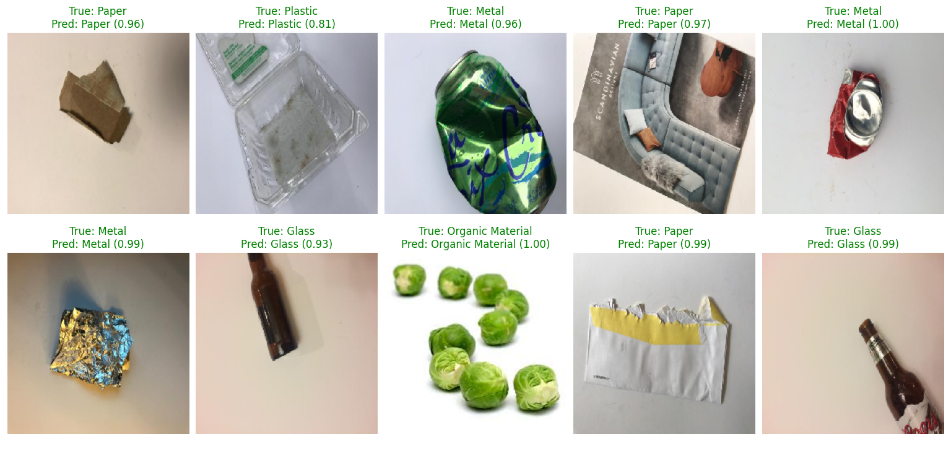
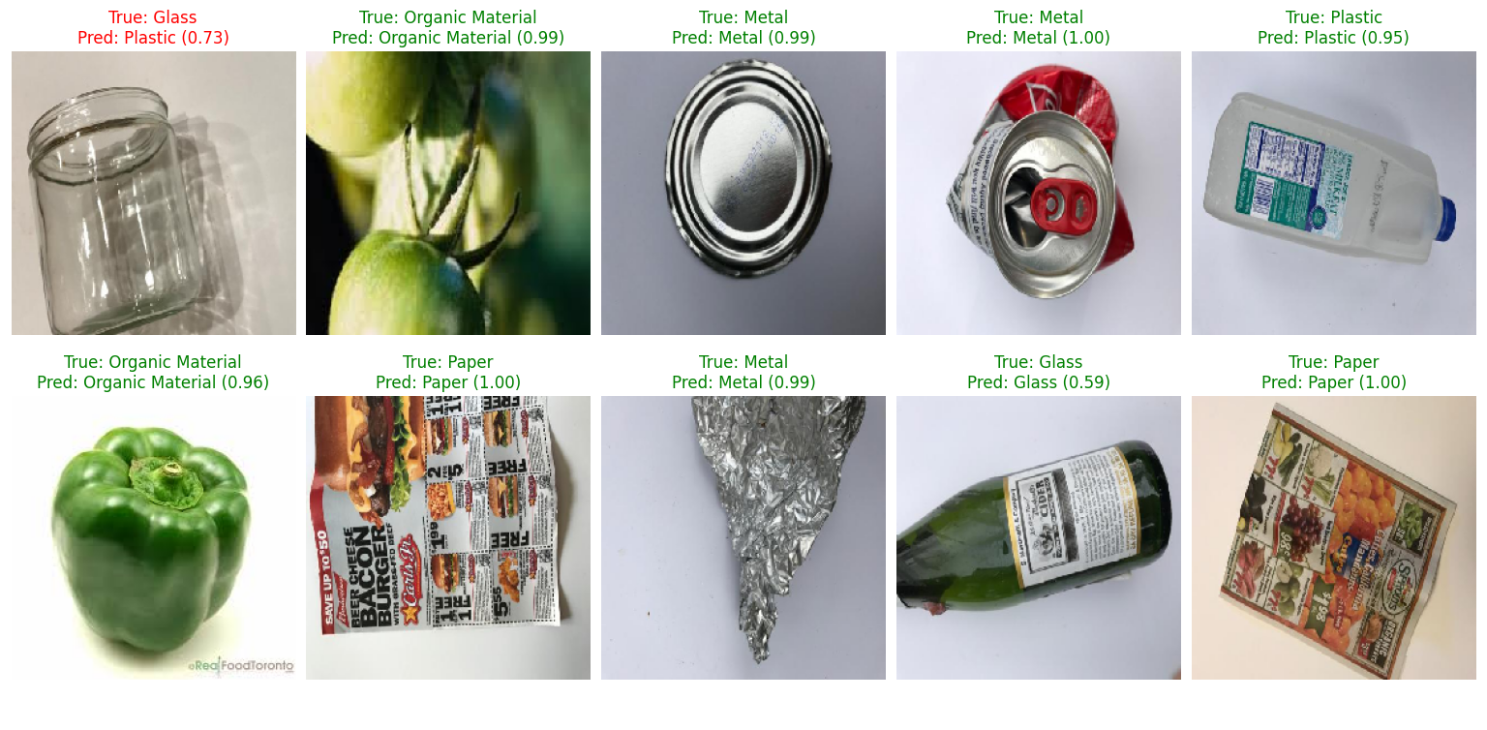

Appendix D – References
- GitHub (n.d.) garythung/trashnet. [online] Available at: https://github.com/garythung/trashnet?tab=readme-ov-file [Accessed 11 May 2025].
- AI with Alex. (2024) A Real-time Trash Detection Web App. Available at: https://www.youtube.com/watch?v=Kn8Hsz1YT78 [Accessed 12 May 2025].
- Kashyap, P. (2020) Understanding Precision, Recall, and F1 Score Metrics. [online] Medium. Available at: https://medium.com/@piyushkashyap045/understanding-precision-recall-and-f1-score-metrics-ea219b908093 [Accessed 15 May 2025].
- Scikit-learn Developers, 2023. Classification metrics - Scikit-learn 1.3.1 documentation. Scikit-learn.org. Available at: https://scikit-learn.org/stable/modules/model_evaluation.html [Accessed 13 May 2025].
- Open Images Dataset V6, 2020. Open Images Dataset. Available at: https://storage.googleapis.com/openimages/web/index.html [Accessed 13 May 2025].
- TensorFlow, 2024. Transfer learning and fine-tuning. TensorFlow.org. Available at: https://www.tensorflow.org/tutorials/images/transfer_learning Accessed 13 May 2025].
- GeeksforGeeks (2025) Introduction to Convolutional Neural Network. [online] Available at: https://www.geeksforgeeks.org/introduction-convolution-neural-network/ [Accessed 13 May 2025].

